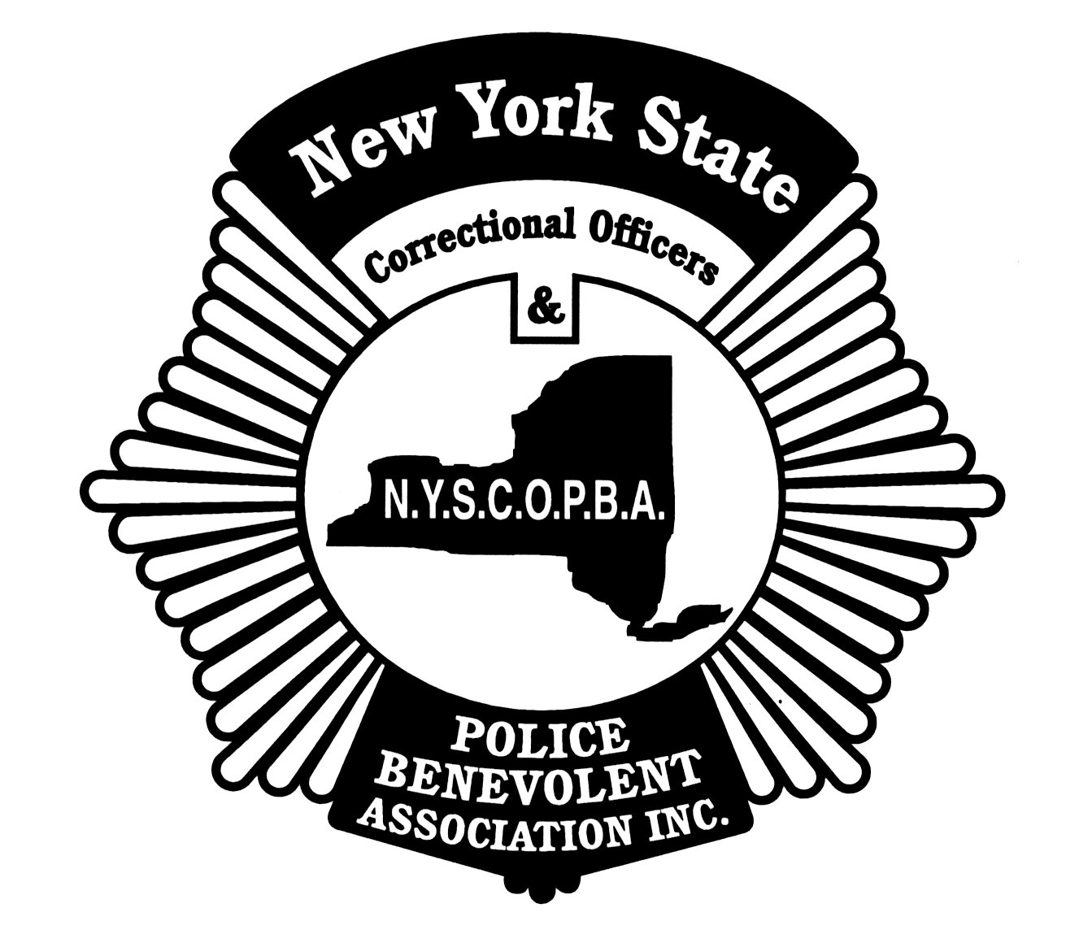

New York State Correctional Officers
& Police Benevolent Association, Inc.
102 Hackett Boulevard- Albany, NY 12209
(518) 427-1551 www.nyscopba.org nyscopba@nyscopba.org

SELF-NOMINATION FORM

I _____________________, am nominating myself for the position of __________________.
Print Print

I have / have not enclosed the required personal information form with my essay (not to exceed 300 words) and my photo for the special election edition of the Independent.

My current facility / worksite is ________________, and my job title is _________________.

The Union position of ______________ (ex. Steward) and length of service held as of June 5, 2017 is _________________ (ex. 2008-2009).

I have been a member in good standing since approximately _________________.

A telephone number I can be reached at is ( )__________________ .

Please circle only one position from the list below:

- President
- Executive Vice President
- Recording Secretary
- Treasurer
- Central Region Vice President
- Mid-Hudson Region Vice President
- Northern Region Vice President
- Southern Region Vice President
- Western Region Vice President
- Law Enforcement Vice President
- Sergeant’s Liaison (Law Enforcement Equivalent)

_________________________
SIGNATURE

______________________
PRINT NAME

_________________________
DATE

